Q1 (a)

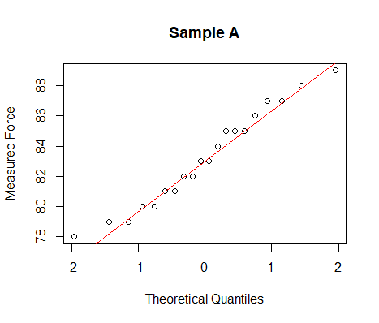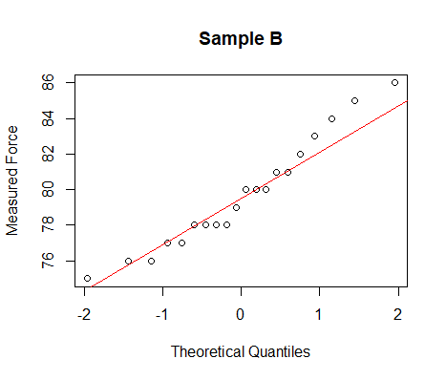

Sample A is normally distributed since most of the points lies on the line,

Sample B is not normally distributed since most of the points does not lie on the line.

(b)

H0: variance of A = variance of B

Ha: variance of A != variance of B

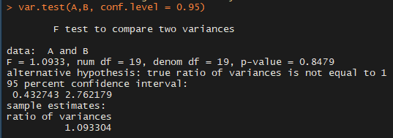

The F-Test suggests that there is no significant difference in variance between sample A and sample B, so we cannot reject H0.

Conclusion: variance of A == variance of B

(c)

H0: µA-µB=0

Ha: µA-µB>0

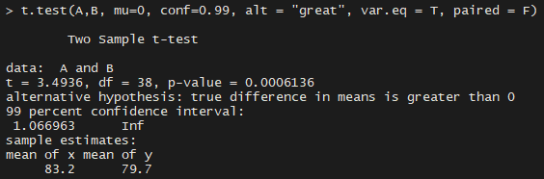

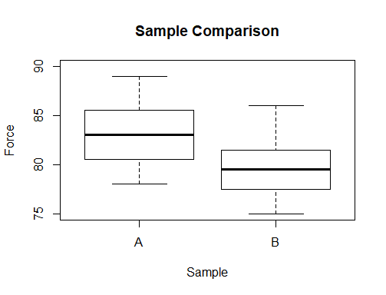

Since p-value(0.0006136) < α(0.01), we can reject H0.

Conclusion:-

Alloy B is stronger than alloy A.

Q2

|  |  |  |  |  |  |  |  |  |  |  |  |
| --- | --- | --- | --- | --- | --- | --- | --- | --- | --- | --- | --- |
| Temperature | 273 | 283 | 293 | 303 | 313 | 323 | 333 | 343 | 353 | 363 | 373 |
| Vapor | 4.6 | 9.2 | 17.5 | 31.8 | 55.3 | 92.5 | 149.4 | 233.7 | 355.1 | 525.8 | 760.0 |

(a)

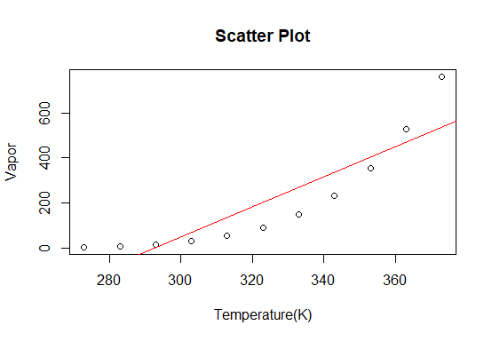

The scatter plot suggests that there is exponential relationship between temperature and vapor pressure.

(b),(c)

ln(vapor) = B0 + B1(1/Temperature) + e

|  |  |  |  |  |  |  |  |  |  |  |  |
| --- | --- | --- | --- | --- | --- | --- | --- | --- | --- | --- | --- |
| 1/Temperature | 1/273 | 1/283 | 1/293 | 1/303 | 1/313 | 1/323 | 1/333 | 1/343 | 1/353 | 1/363 | 1/373 |
| ln(Vapor) | 1.526 | 2.219 | 2.862 | 3.460 | 4.013 | 4.527 | 5.007 | 5.454 | 5.872 | 6.265 | 6.633 |

(d)

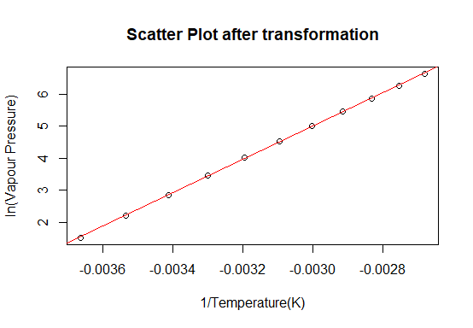

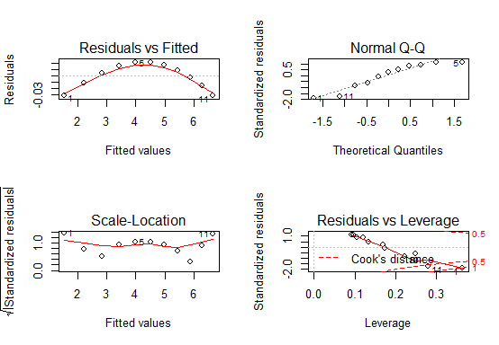

(e)

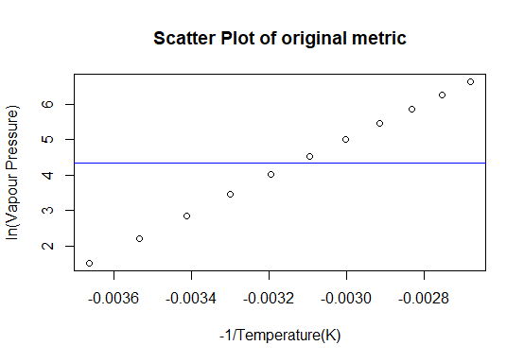

Q3

|  |  |
| --- | --- |
| Time (min) | Length (cm) |
| 10 | 0.6 |
| 20 | 1.8 |
| 30 | 2.9 |
| 40 | 4 |
| 50 | 5 |
| 60 | 6.1 |
| 70 | 7.9 |
| 80 | 10.1 |
| 90 | 10.9 |
| 100 | 12.7 |
| 110 | 14.4 |
| 120 | 16.6 |
| 130 | 18.1 |
| 140 | 19.9 |
| 150 | 21 |
| 160 | 23.4 |
| 170 | 24.7 |
| 180 | 27.8 |

(a)

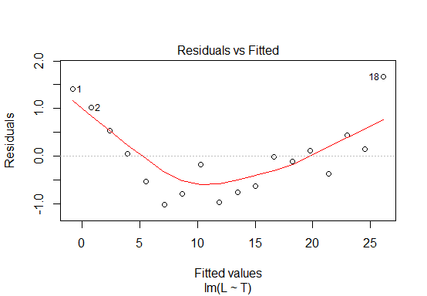

Linear model is not appropriate for this dataset

(b)

